

# Apple iPad Pro 11 inches 5G

## Type of device: Tablet

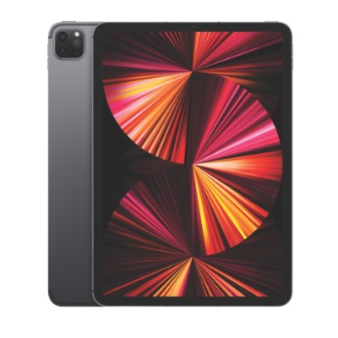

Actual Display Size : 11 inches

Operating System : Apple IOS

Version Number : iPadOS 14

Network Capability : 3G,4G,5G

Year of Release : 2021

Average Price : $2273 as of 28 09 2021

Internet Access : Wi-Fi and Mobile Broadband

## Accessibility Features:

### Cognitive

* Additional Instructions
* Copy and Paste
* Flicker Free Display
* GPS
* Photo Telephone List
* Screen Timeout Disabled
* Simple Instructions
* Simple Reminders
* Simplify Display

Voice Notes

### Hearing Impairment and Deaf

* Allows for sign language communication
* Bluetooth or Wi-Fi
* Closed Captioning
* Front Facing Camera
* Hearing Aid Microphone Coupling
* Hearing Aid Telecoil Coupling
* Text Messaging/SMS
* Vibrating Alerts - Adjustable
* Video Communications - Two-way

Visual Alerts - Incoming Calls

### Vision

* Accessibility APIs supported
* Battery Alert - Audible
* Bluetooth or Wi-Fi
* Braille Display Support
* Brightness Adjustable
* Dictation / Speech-to-Text
* High Contrast Mode
* Personalised Shortcuts
* Power Cue
* Screen Magnifier
* Screen Reader
* Text Size Adjustable
* Voice Control /Personal Assistant

Voiced Menus

### Speech

* Allows for sign language communication
* Bluetooth or Wi-Fi
* Messaging Options - Email
* Messaging Options - IM
* Messaging Options - MMS
* Predictive Text

SMS Personalisation and Reuse

### Physical

* Bluetooth or Wi-Fi
* Dictation / Speech-to-Text
* Gesture Based Navigation
* Predictive Text
* Reduced hand movement option
* Speaker-phone option
* Stylus or Prosthetic Device support
* Switch control option
* Visible Focus Indicators
* Voice Control / Personal Assistant
* Voice Recognition for Accessing Features

Voice Recognition for Dialling

## How and where to get it from?

You can buy this phone from [Apple](https://www.apple.com/au/shop/buy-ipad/ipad-pro), [Optus](https://www.optus.com.au/mobile/tablets/apple/ipad-pro-3-11-5g?contractLength=36), [Vodafone](https://www.vodafone.com.au/tablets/ipad-pro-11-inch?capacity=128GB&color=Silver&contractTerm=36), [Retravision](https://www.retravision.com.au/apple-ipad-pro-11inch-128gb-wi-fi-cellular-space-grey-mhw53xa), [Officeworks](https://www.officeworks.com.au/shop/officeworks/search?q=iPad%20Pro%2011%20inch%20wifi%20%2B%20cellular&view=grid&page=1&sortBy=bestmatch), [JB Hi-Fi](https://www.jbhifi.com.au/search?query=Apple%20iPad%20Pro%2011%20inch%20Wi-Fi%20+%20Cellular&page=1), and other retailers.

## More information is available on:

[Apple iPad (5th Generation) Pro Webpage](https://www.apple.com/au/ipad-pro/)

[Apple iPad (5th Generation) Pro Specifications Webpage](https://www.apple.com/au/ipad-pro/specs/)

[Apple iPad (5th Generation) User Manual](https://support.apple.com/en-au/guide/ipad/welcome/ipados)

[Apple Accessibility Webpage](https://www.apple.com/au/accessibility/)